**Header – Drawer, children prop**

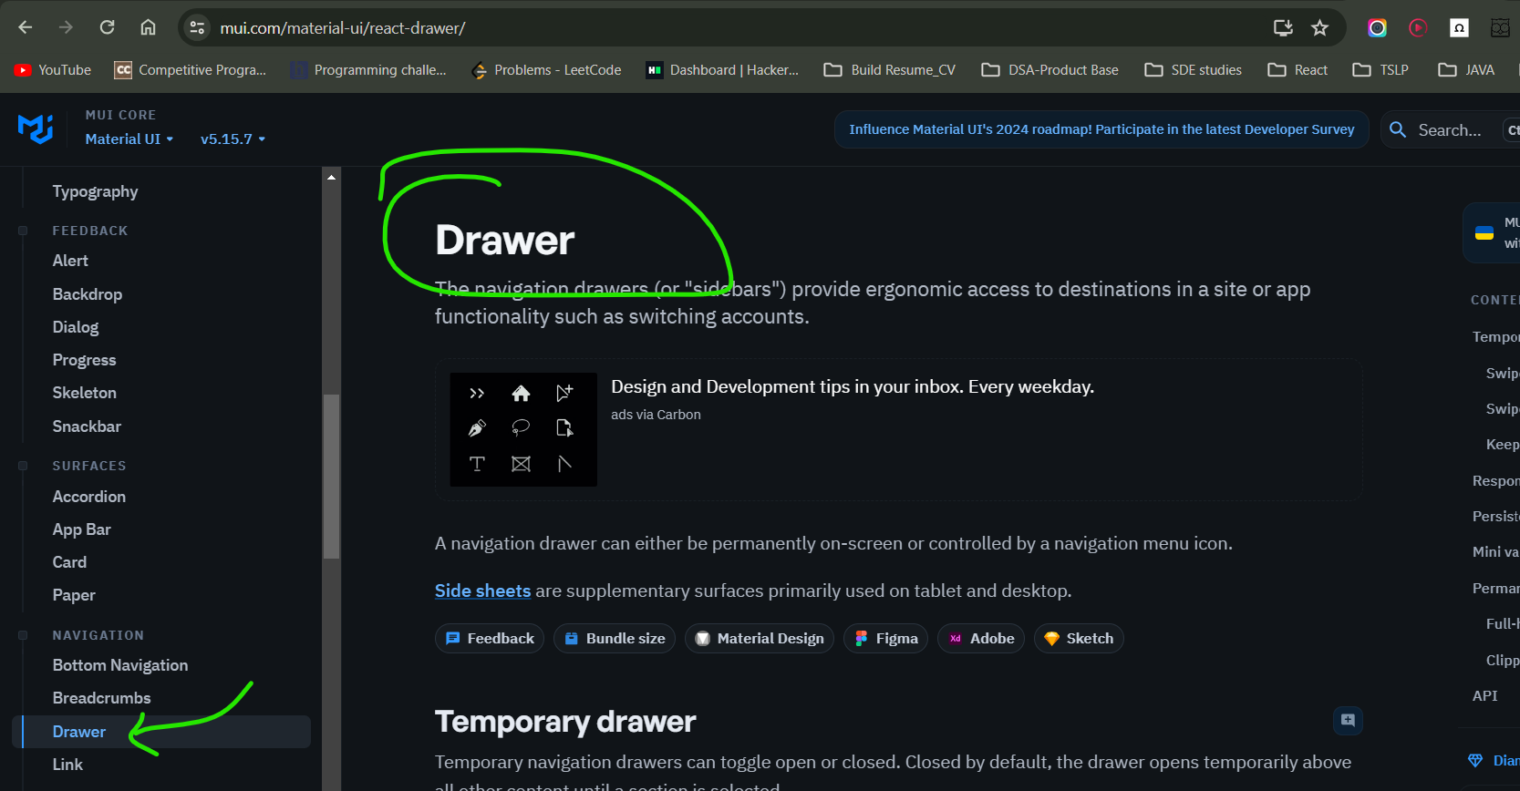

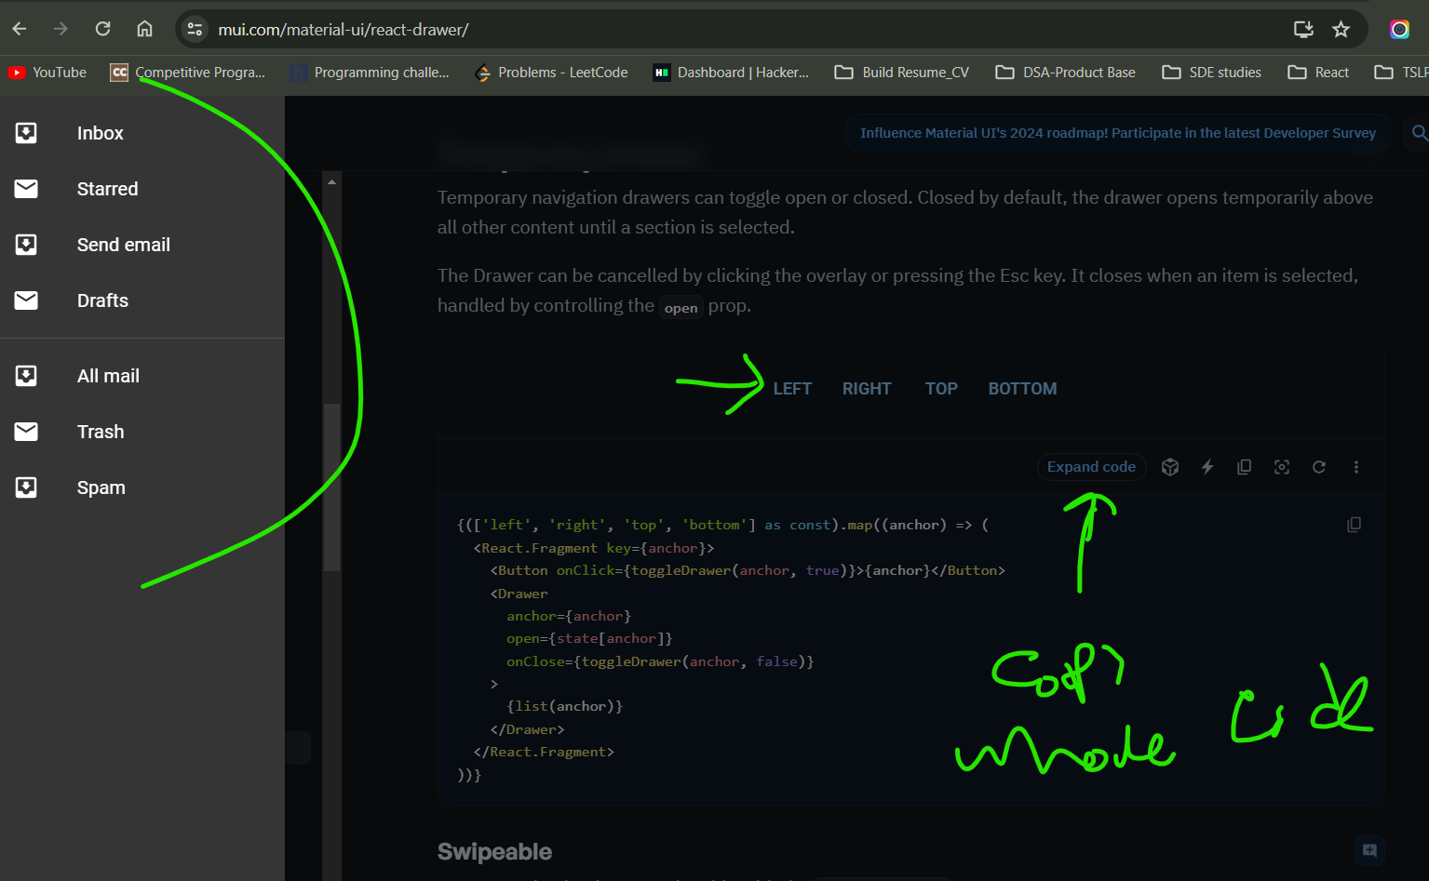

Create a component & name it as SideDrawer.js

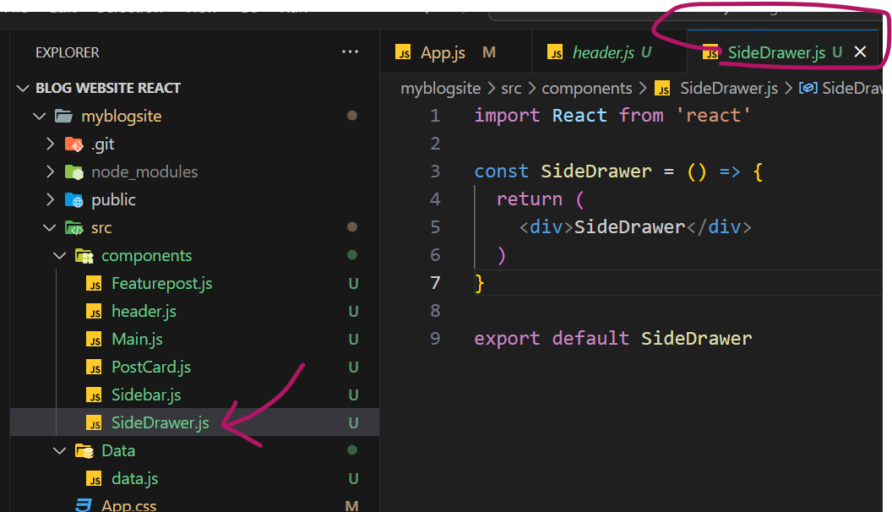

In Header.JS, Wrap the button with new component

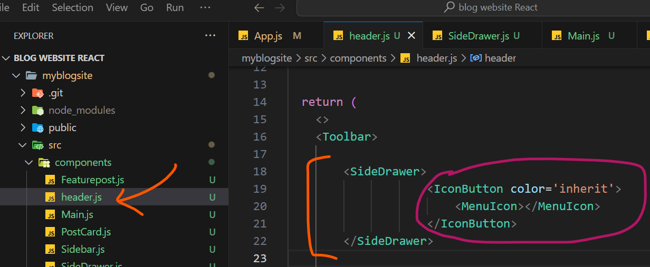

Now paste this Temporary Drawer code in SideDrawer.js File

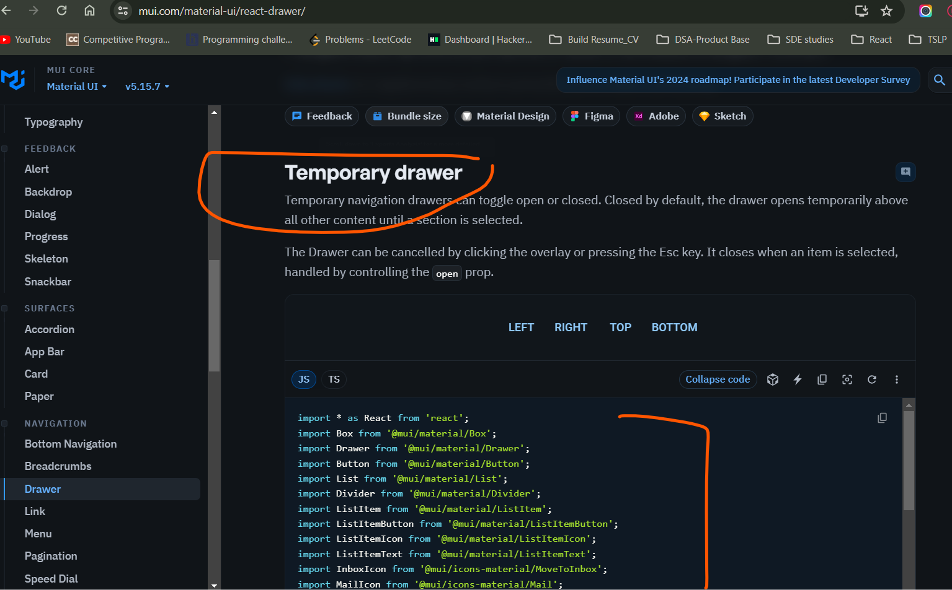

**What changes we need to make in our VS code?**

As we want only left side drawer, so delete rest of the directions

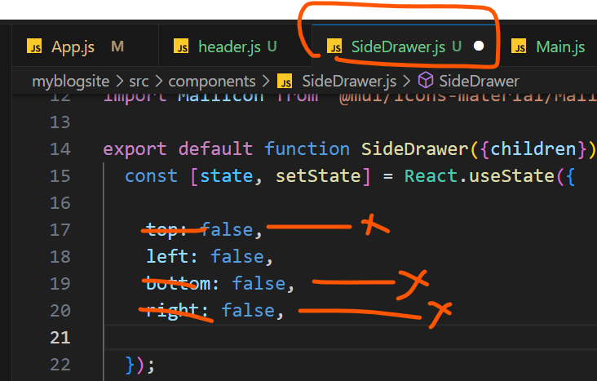

As we only need left drawer so delete map

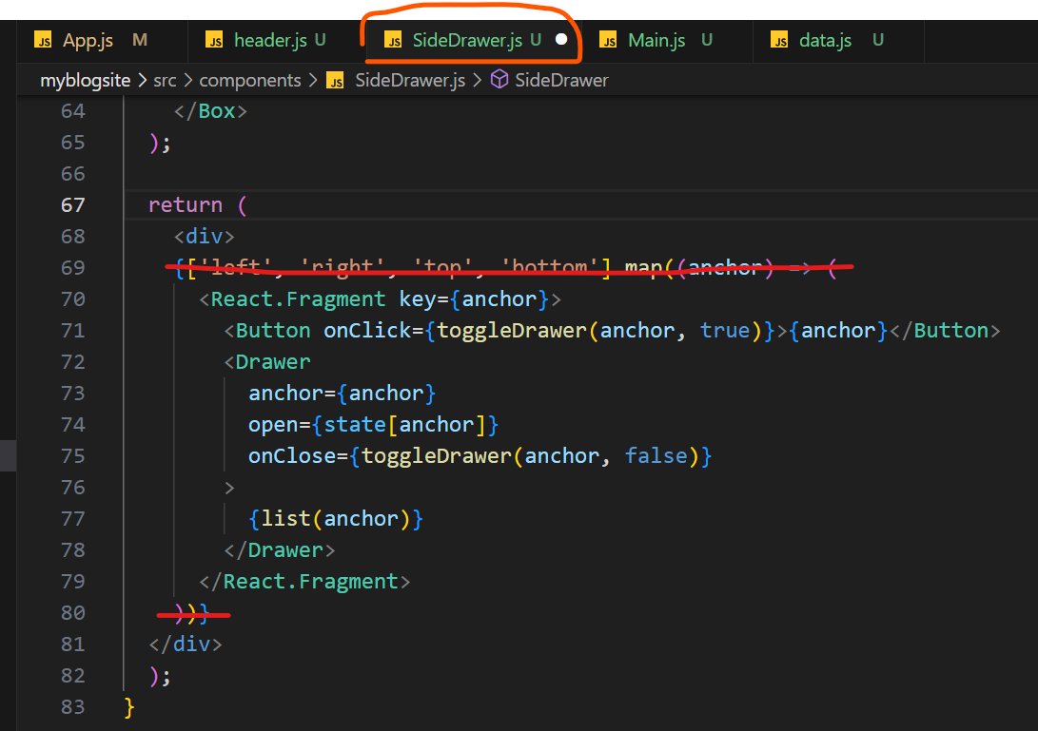

Now Replace all anchors to “Left”

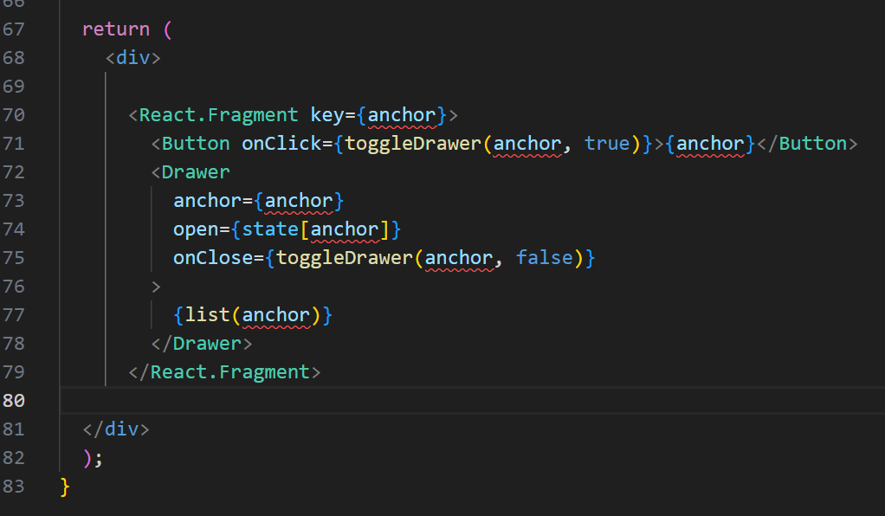

After Replacing

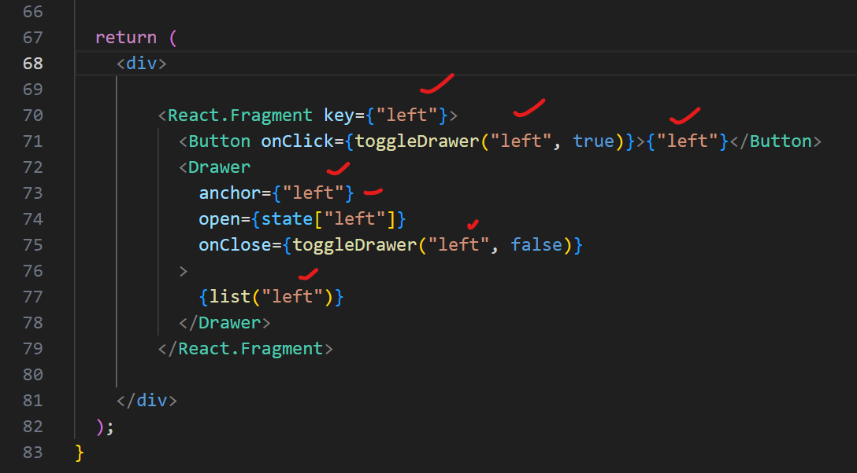

Now Check in Browser

If you click this, it will open side bar

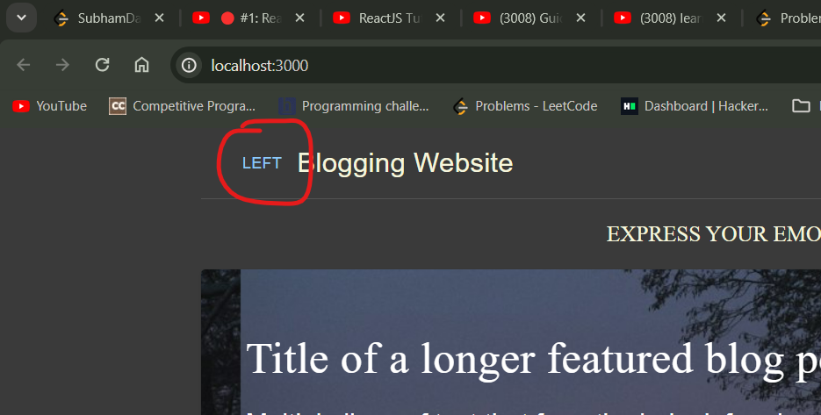

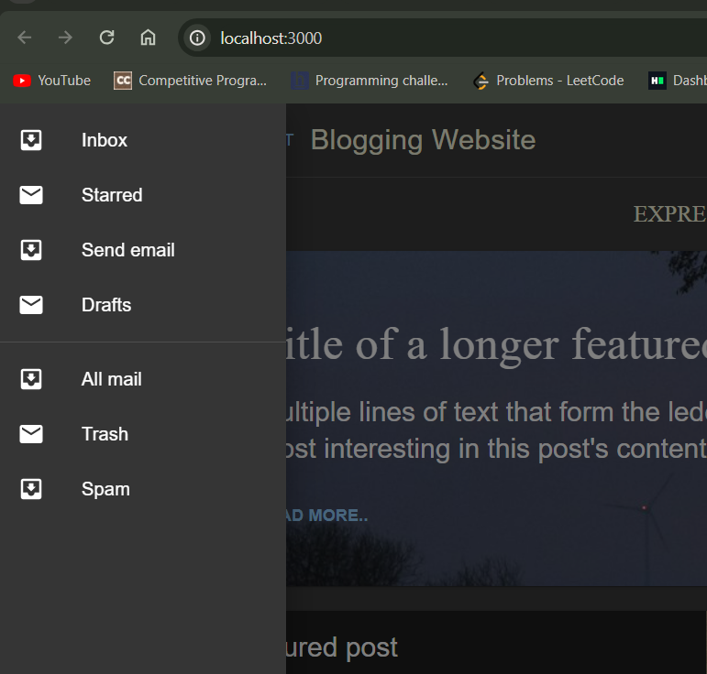

Now in Header.js. we have wrapped the Button. To render it we need to get it in SideBar.js

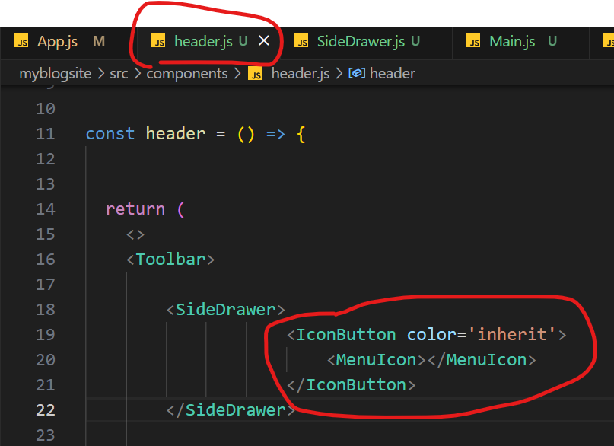

So in Sidebar.js

Pass it as children

{children} is a way to pass the state data to a component as the props.

It is a react build in keyword

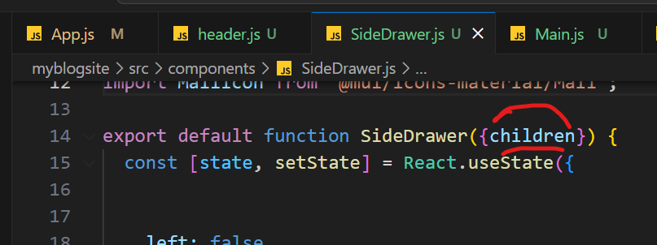

& call it in Button tag

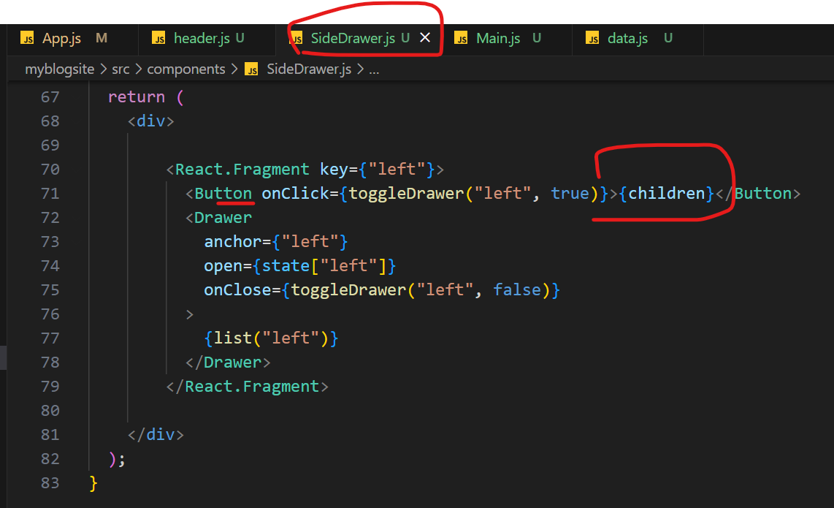

Done !! Working

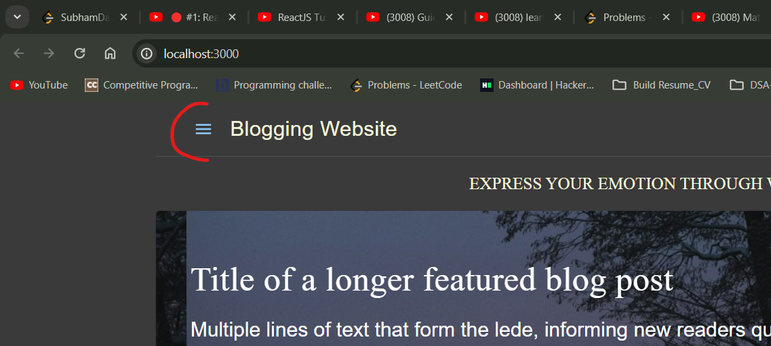

=========================== END========================